General Information

<http://www.sensorland.com/HowPage028.html>

**THE 4-20mA CURRENT LOOP**

The 4-2OmA current loop has been with us for so long that it's become rather taken for granted in the industrial and process sectors alike. Its popularity comes from its ease of use and its performance. However, just because something is that ubiquitous doesn't mean we're all necessarily getting the best out of our current loops.

A big benefit of the current loop is its simple wiring just the two wires. The supply voltage and measuring current are supplied over the same two wires. Zero offset of the base current (ie. 4mA) makes cable break detection simple: if the current suddenly drops to zero, you have a cable break. In addition, the current signal is immune to any stray electrical  
interference, and a current signal can be transmitted over long distances.

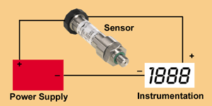

*Typical wiring for current output transducer.*

You can think of the current loop itself as being analogous to a water system. You have a hose pipe (the wires) and a source tap (the power supply). You have a spray gun that regulates the flow (the transducer). You can have other equipment on the line, but it all has to be connected  
together in a ring Ioop. The more holes (devices) you have on the hose pipe, the higher the pressure will be required from the tap. Relating all that back to the current loop, you see a power supply, a transducer and one or more pieces of instrumentation all connected together in a ring.

You'll often hear things referred to as being either active or passive. Some instruments have an active output which includes both the control of the current in the loop as well as provide the supply voltage. This is typically specified as being a 4-20mA output into 10-750 Ohms, or something similar. A passive input would be a simple resistor input that  
has a voltage drop to be factored into the equation once the supply voltage is chosen. This is typically specified as a 4-20mA input into 10 Ohm.

Working out the power supply requirement is a simple matter of adding up all the units in the loop at maximum current of 20mA. As an example, suppose you have a sensor 'regulator' which requires minimum 12V DC and instrumentation of 10 Ohm input:

10 Ohm x 20mA = 0.2V

So, for this circuit, a 12.2V minimum supply is required, the sensor's maximum voltage might be specified at 30V, so a 24V supply would be all the circuit requirements with spare capacity to boot.

In order to measure the current loop it is necessary to break the loop and insert a current meter into it. You can also measure the voltage across the various components by in the loop, such as the voltage out of the power supply, the voltage over a sensor, and the voltages over the various pieces of instrumentation. This information will give you a  
good picture of what is happening within the loop.

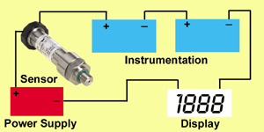

*Multi-instrument 4-20mA current loop with panel meter, chart recorder, computers, etc.*

A question which is sometimes asked is whether it is possible to use single power supply over several loops. This is possible, but you have to ensure that the power supply can give enough current to meet the needs of multiple loops. It is also the case that the current loops will have the same zero negative reference, which can cause a ground loop. In addition, interference from one loop can affect all the other loops driven from the one supply.